Activities I could do in my free time
Some examples |  | You can write or draw activities you would like to do here
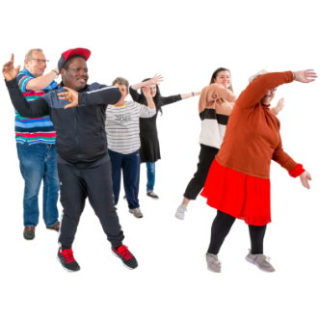 | dance
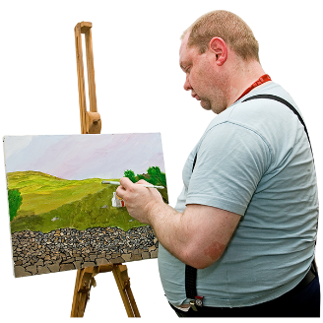 | art
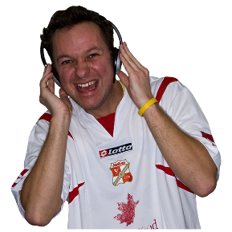 | listen to music

Activities I could do in my free time

Authors
Janelle Weise¹, Bronwyn Newman¹, Claire Eagleson¹, Karen Fisher², and Julian Trollor¹.

¹Department of Developmental Disability Neuropsychiatry, School of Psychiatry, Faculty of Medicine, UNSW Sydney
²Social Policy Research Centre, Faculty of Arts and Social Sciences, UNSW Sydney

This planning sheet is part of a series of easy read resources explaining
- how people can access public mental health services in New South Wales and
- what they can expect.

For information on how to support people to use easy read see Making mental health information accessible for people with intellectual disability – A Toolkit

© Department of Developmental Disability Neuropsychiatry UNSW Sydney 26.11.20 v1

